## Azure Static Website on Blob Storage

* + 1. Storage Account resource

4/21/20

1. Az Portal > dh account > Create a resource > Storage > Storage account
2. Create storage account
   1. Subscription: 2f106c03…
   2. Resource Group: new – DhmcBlobStorageGrp
   3. Storage account name: dhmcstaticsite
   4. Replication: Locally-redundant storage (LRS)
3. Networking:
4. Advanced:
5. Tags:
6. Review & Create:
7. Create:
8. Go to resource
9. DhmcStaticSite
   1. Settings > Static website
   2. Enabled
   3. Index doc name: index.html
   4. Error doc path: error.html
   5. Save
   6. <https://dhmcstaticsite.z19.web.core.windows.net/>
   7. $web container
10. Home > Dhmcstaticsite
    1. Open in Explorer
       1. Download Azure Storage Explorer
    2. Drag to AzStExpl $web container: C:\backup21\backupFolders21\DSS\DSS.WebSites_Investigation\DhMusicCharts\AwsWebsite
    3. Upload folder – select ‘AwsWebsite’

<https://dhmcstaticsite.blob.core.windows.net/$web/AwsWebsite/index.html>

* 1. this was returning 404 Not Found
  2. That should work by default.
     1. I found a stackoverflow :

<https://stackoverflow.com/questions/56057614/azure-storage-static-website-error-resource-not-found-or-content-doesnt-exist>

* 1. [Home](https://portal.azure.com/#home) > [dhmcstaticsite | Static website](https://portal.azure.com/#@dhorriganmsn.onmicrosoft.com/resource/subscriptions/2f106c03-9b32-42ee-be11-99d0286aba1a/resourcegroups/DhmcBlobStorageGrp/providers/Microsoft.Storage/storageAccounts/dhmcstaticsite/staticWebsite) > [$web](https://portal.azure.com/#blade/Microsoft_Azure_Storage/ContainerMenuBlade/overview/storageAccountId/%2Fsubscriptions%2F2f106c03-9b32-42ee-be11-99d0286aba1a%2Fresourcegroups%2FDhmcBlobStorageGrp%2Fproviders%2FMicrosoft.Storage%2FstorageAccounts%2Fdhmcstaticsite/path/%24web)
     1. “Change access level” > Change the access level of container ‘$web’
     2. I changed from ‘Private’ to ‘Blob’
  2. Now I can see the root page that is using the css file
  3. I can edit the css file, upload (replace) it, and refresh the page and font has changed

<https://dhmcstaticsite.blob.core.windows.net/$web/AwsWebsite/SongList.html>

* + 1. Azure Storage Explorer

4/21/20

<https://azure.microsoft.com/en-us/features/storage-explorer/>

Download now

StorageExplorer.exe

Microsoft Azure Storage Explorer

Sign In > Add an Azure Account

[dhorrigan@msn.com](mailto:dhorrigan@msn.com) / rr

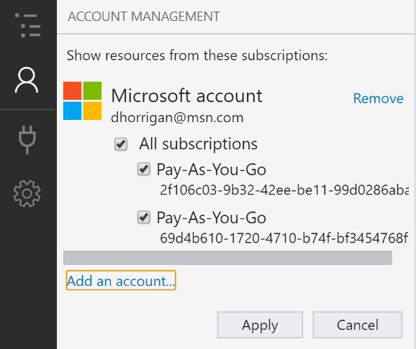

Apply

